Experiment 2
We need to install Microsoft Visual C# 2010 Online,and Here is the download address
link：https://pan.baidu.com/s/1RFruKw25ZnnK-a18bXn86A
Extraction code：u94p
Step:
- Create a database called MDB

CREATE DATABASE MDB;
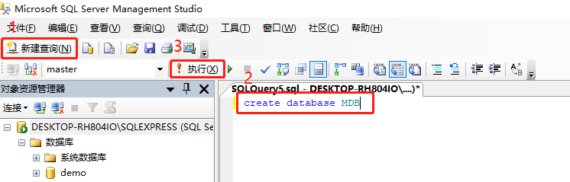
- create tables
Enter the following SQL statement and execute the query

use MDB

CREATE TABLE Student (
SID varchar(10) NOT NULL ,
Sname nvarchar(10) NOT NULL ,
Sex nvarchar(5) check(sex='男' or sex='女') NOT NULL,
SchoolAge int check(Schoolage > 10 and Schoolage < 50) NOT NULL ,
SchoolYear int NOT NULL ,
Class nvarchar(20) NOT NULL ,
primary key(SID)
)

CREATE TABLE Course (
CID varchar(7) NOT NULL ,
Cname nvarchar(10) NOT NULL ,
TID varchar(5) NOT NULL ,
Credit int NOT NULL ,
Grade varchar(30) NOT NULL ,
CancelYear int NULL ,
primary key(CID)
)

CREATE TABLE Teacher (
TID varchar(5) NOT NULL ,
Tname nvarchar(10) NOT NULL ,
Course nvarchar(10) NOT NULL ,
primary key(TID)
)

CREATE TABLE Choose (
SID varchar(10) NOT NULL,
CID varchar(7) NOT NULL,
TID varchar(5) NOT NULL ,
Score int NULL ,
ChooseYear int NOT NULL ,
foreign key(SID) references Student(SID),
foreign key(CID) references Course(CID),
foreign key(TID) references Teacher(TID)
)

CREATE TABLE Permission1 (
SID varchar(10) NOT NULL ,
SPW varchar(10) NOT NULL ,
primary key(SID)
)

CREATE TABLE Permission2 (
TID varchar(5) NOT NULL ,
TPW varchar(10) NOT NULL ,
primary key(TID)
)

CREATE TABLE Permission3 (
MID varchar(7) NOT NULL ,
MPW varchar(10) NOT NULL ,
primary key(MID)
)

- Then we use C# to design UI:
Create a new project and select a Windows window program
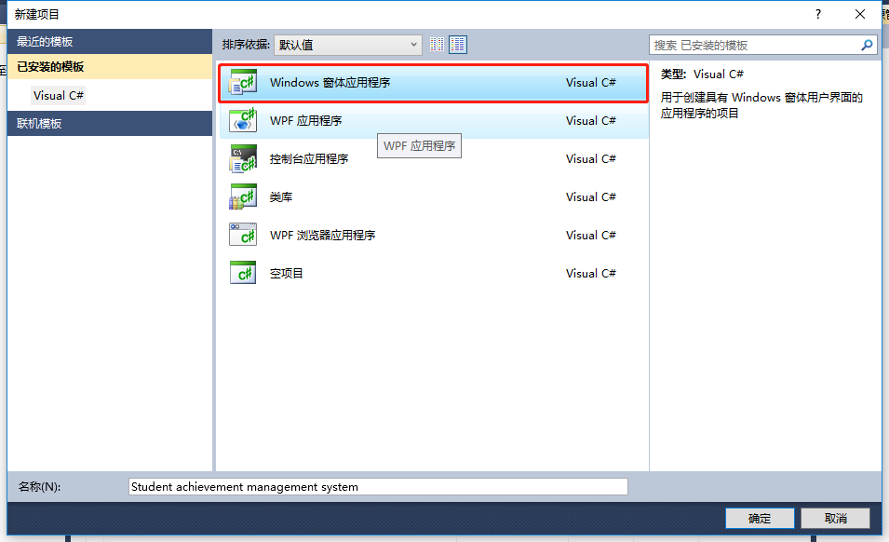
Create a form in the project
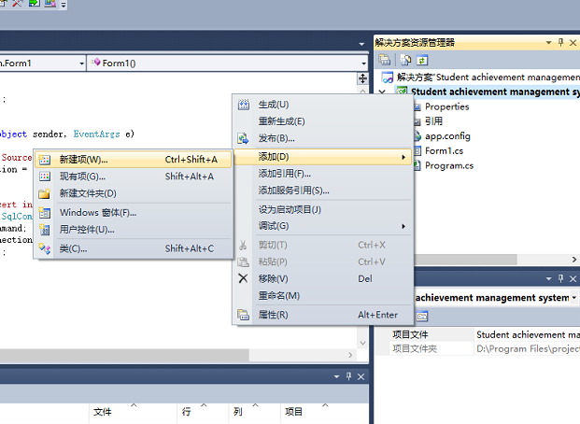
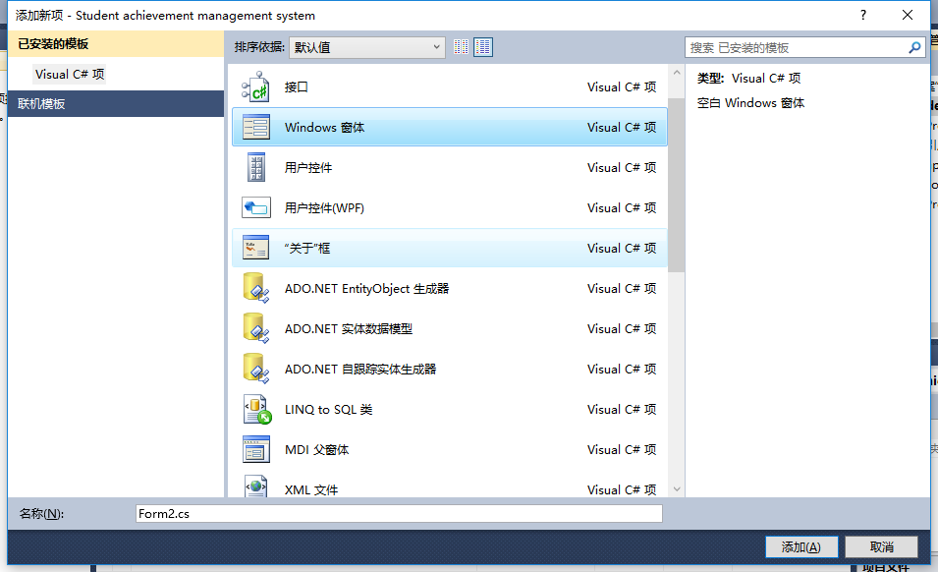
Then We just need to drag the component on the left to the form to complete the UI design
Here are some design examples, you don't have to be completely consistent with the examples in the following, just meet the requirements of the problem.
Form1: The login interface:
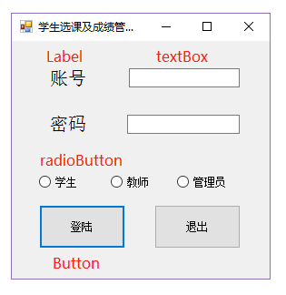
Form2: Student interface:
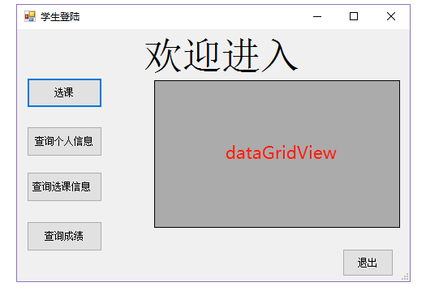
For the course choose；
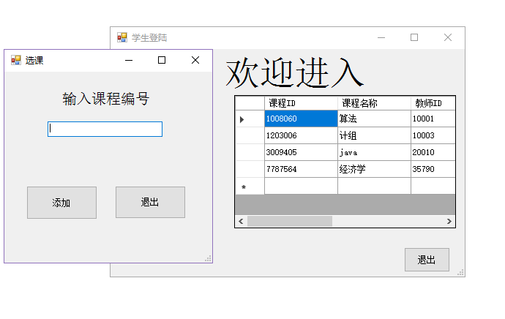

Form3:Teacher interface:
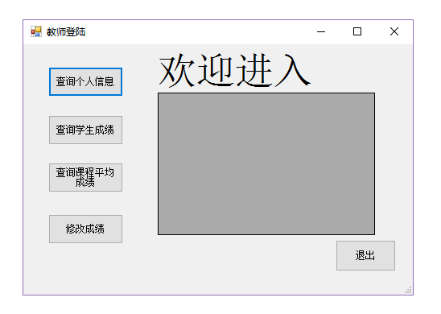
For the modify the score:
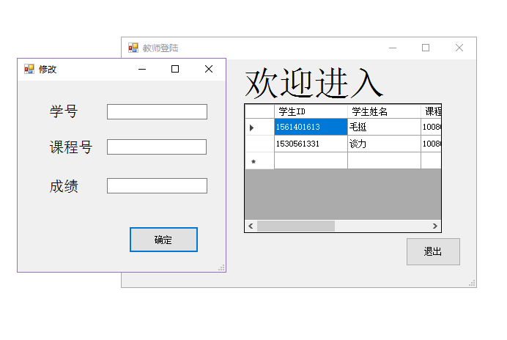
Form4: Management interface:
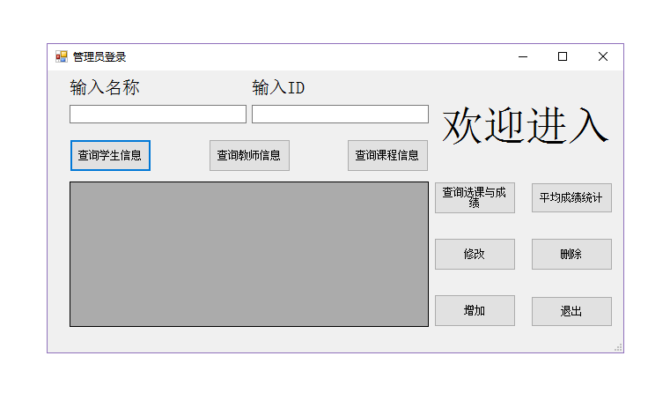
For the query choose:
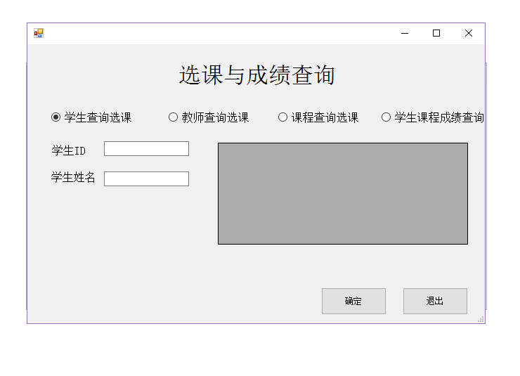
For the query score:
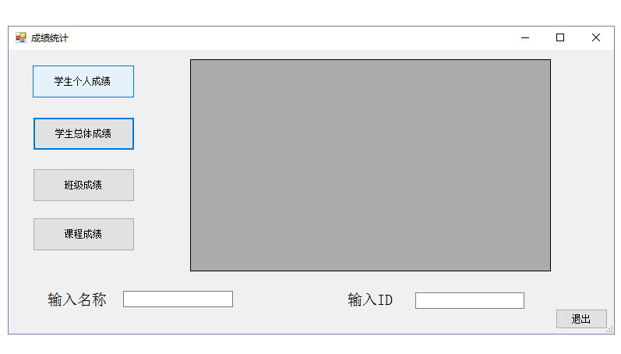
For the modify:
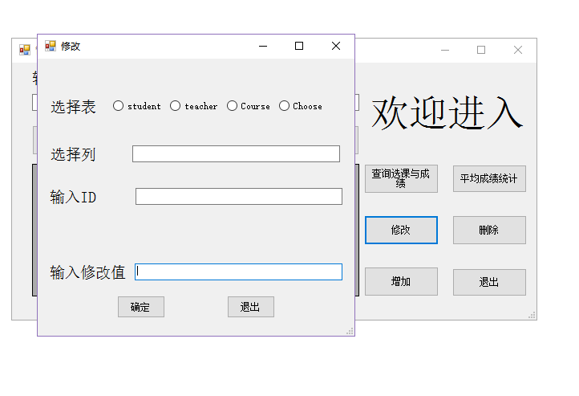
For the delete:
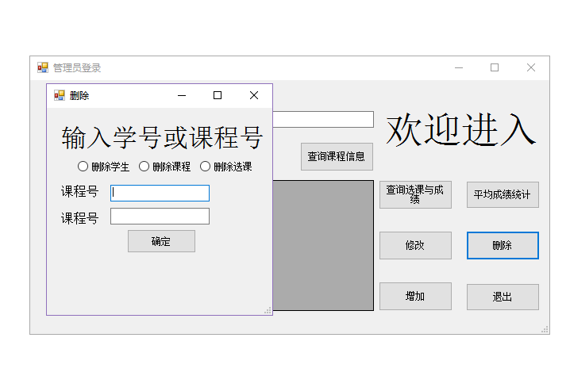
For the addition:
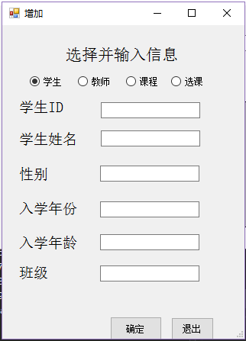

The mainly connection is:
Form 2 Form 5

Form 1 Form 3 Form 6

Form 4 Form 7
Form 8
Form 9
Form 10
Form 11

- For the every main form we need to realize the function:
Next let's see how to connect to the database and jump between tables, take the Form1 for example
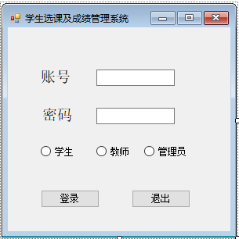

To get the input in the text box, we need to double-click the text box and save the text content with the string variable
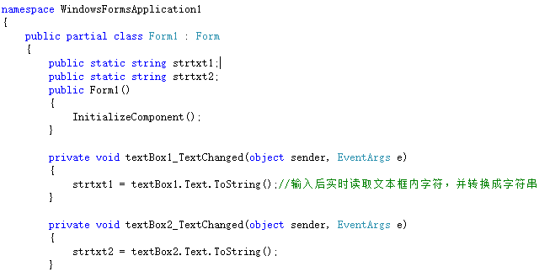
Next, we will see how to realize the login function. After we obtain the account and password, we need to determine the user type according to the checked value in RadioButton, and then perform database query to compare with the user and password in the database. If the queried value is not empty, the login is judged to be successful
Double click the login button and enter the following statement
- private void button1_Click(object sender, EventArgs e)

- string conn = @"Data Source=(local);Initial Catalog=MDB;Integrated Security=True;";
- SqlConnection connection = new SqlConnection(conn);//连接数据库
- connection.Open();

- if (radioButton3.Checked == true) {//如果'管理员'单选框被选中，点击登录则执行如下语句
- string command = "select count(MID) from permission3 where MID=" + strtxt1;//自定义sql查询语言
- SqlCommand mySqlCommand = new SqlCommand(command, connection);
- int i = Convert.ToInt32(mySqlCommand.ExecuteScalar());//把查询结果转换成数字，如果没有查询到相应MID的账号，查询结果为0
- if (i == 0) MessageBox.Show("用户不存在");
- else {
- command = "select count(MID) from permission3 where MID="+strtxt1+"and MPW=" + strtxt2;
- SqlCommand sql = new SqlCommand(command, connection);//sqlcommand执行sql命令，注意函参
- int j = Convert.ToInt32(sql.ExecuteScalar());
- if (j !=0 )
- {
- MessageBox.Show("成功");//弹出提示框，显示成功
- Form4 f4 = new Form4();//跳转到第另一个写好的界面
- f4.ShowDialog();
- this.Close();//关闭登录界面
- }
- else
- MessageBox.Show("密码错误");
- }
- }

Finally, let's see how to make the form display the queried data, and we take the average score of inquiry students for example
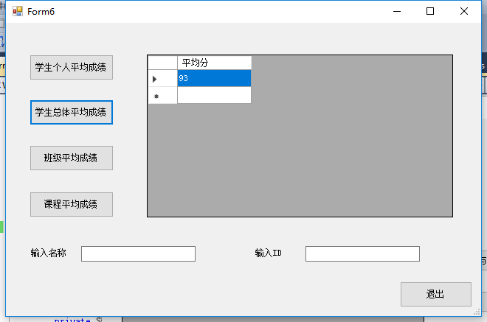
Double click on the student average overall score
- private void button2_Click(object sender, EventArgs e)

- conn = @"Data Source=(local);Initial Catalog=MDB;Integrated Security=True;";
- SqlConnection connection = new SqlConnection(conn);//数据库连接
- connection.Open();

- command = "select avg(score) as '平均分' from Choose ch";//定义sql查询语句
- SqlCommand sqm = new SqlCommand();
- sqm.CommandText = command;
- sqm.Connection = connection;
- //sqm.ExecuteNonQuery();单纯的执行sql语句

- //执行sql语句并让它显示在dataGridView中
- SqlDataAdapter sda = new SqlDataAdapter(sqm);
- DataSet ds = new DataSet();
- sda.Fill(ds);//执行sql语句并在dataGridView中显示
- dataGridView1.DataSource = ds.Tables[0].DefaultView;

Finally, let's look at the general statements for connecting to the database

- conn = @"Data Source=(local);Initial Catalog=MDB;Integrated Security=True;";
- SqlConnection connection = new SqlConnection(conn);//数据库连接
- connection.Open();

- command = "select avg(score) as '平均分' from Choose ch";//定义sql查询语句
- SqlCommand sqm = new SqlCommand();
- sqm.CommandText = command;
- sqm.Connection = connection;
- sqm.ExecuteNonQuery();//单纯的执行sql语句

For database connection statements "Data Source=(local);Initial Catalog=MDB;Integrated Security=True;"
The value of Data Source equals to the server name in SQL Server
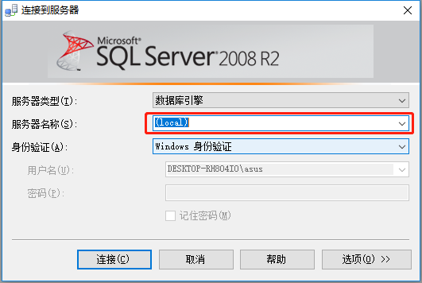
The value of Initial Catalog equals to the database name in SQL Serve
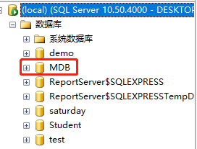

User Manual
Login to Manage System
Users need to type in users' ID and password, and choose correct type of users i.e. student， teacher, administrator. We have a initial ID and password for three different types of the users to log in. You should choose the right user type, otherwise the system will send an error message to you. Be informed that different user-types aim to different user interface afterward.

Student Interface
In student interface, there are four buttons to active different functions:
1) Enroll course;
2) query personal information;
3) query personal score;
4) query course enrollment info.
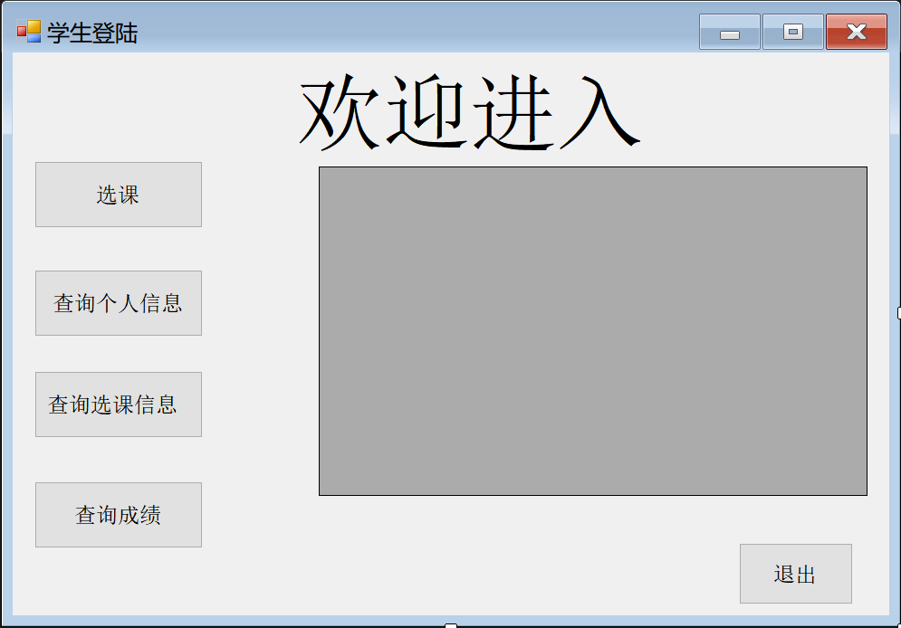
When you click one of them, the datagridview will show the result. Especially, when you click the choose button, you will log in a new form to input the course ID information for choosing the course.
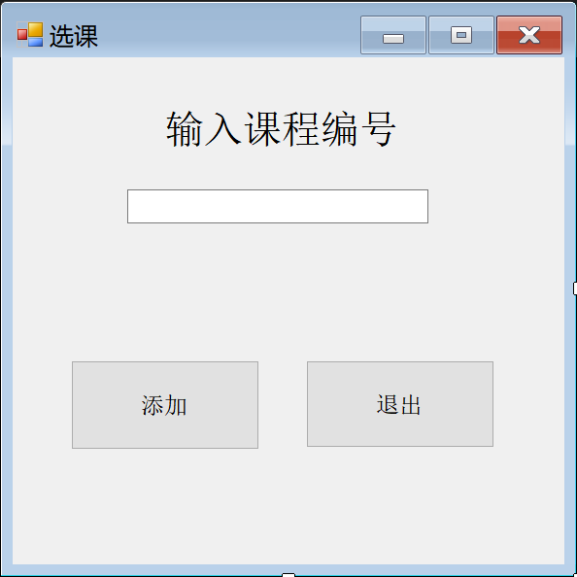
Teacher Interface
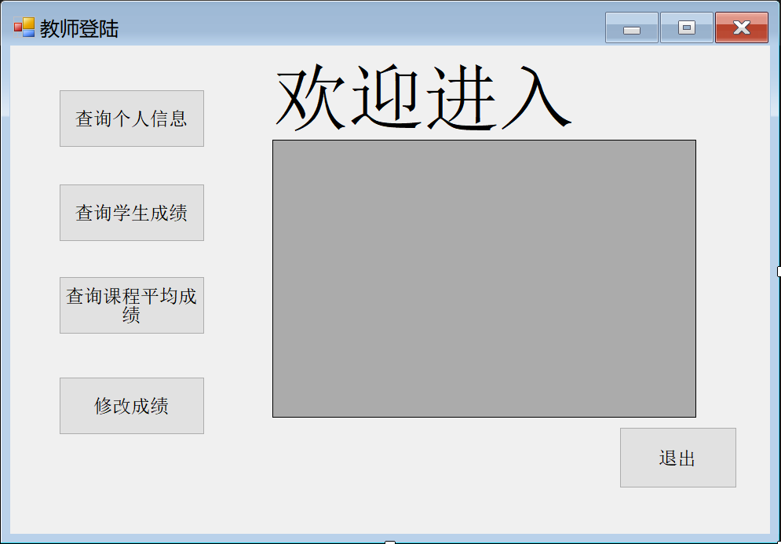There are a list of four button for:
1) Query personal information;
2) Query course score;
3) Query course average score;
4) Modify the score.
When you click one of them, the datagridview will show the result. Especially, when you click the modify button, you will log in a new form to input the student ID and the score you want to modify to change the score.
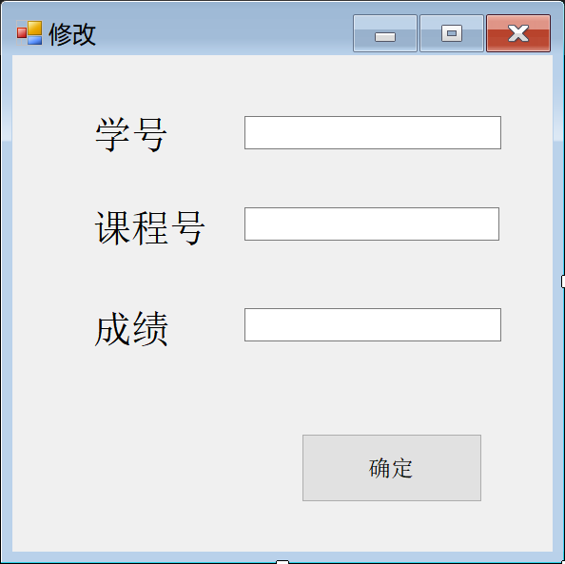

Administrator Interface
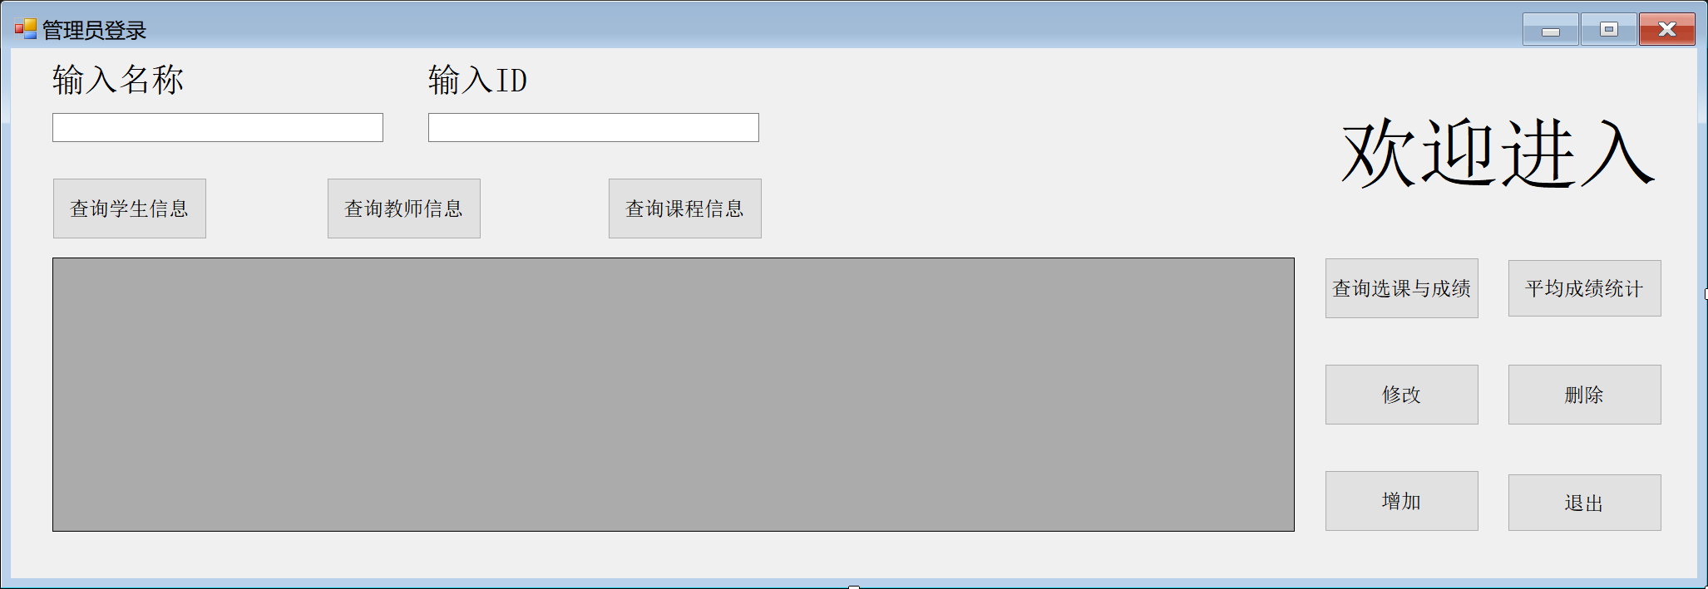In this interface, there are eight buttons to implement different functions:
1) Query student personal information;
2) Query teacher personal information;
3) Query course information;
For the first three functions, we support conditional querying, which uses the two textboxs to input ID and name to access information. All information will be shown if users don't input any id or name.
4) Query choose information;
As for choosing information, you will log in a new form to choose four types of the query method. You can use id or name for student, teacher, course to query the choose information. Another type is to query the score for the course.
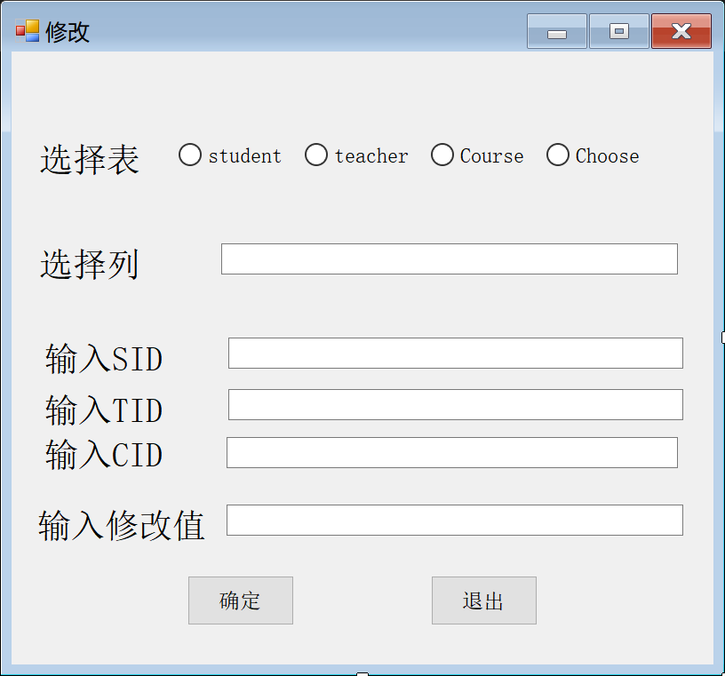
5) Query average score information;
You will log in a new form to query the avg score, you can query course, student sum, student personal, class four types of the avg score by input the ID or name. For the sixth function, you will log in a new form to modify the all information of the database except the score.
6) modify;
7) addition;
You will log in a new form to add student, teacher, course choice information.
8) delete.
You will log a new form to delete student, teacher, choose by input the information.

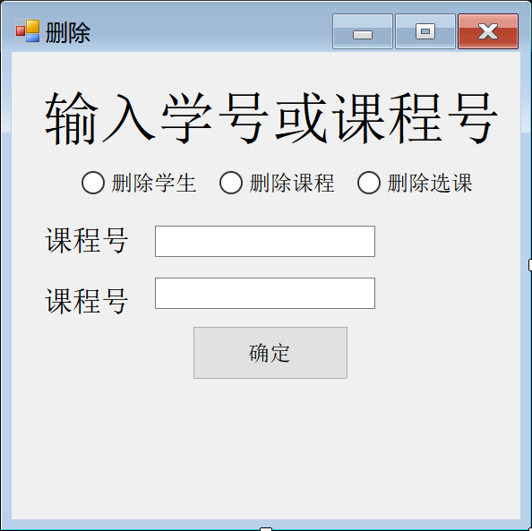
- Test
We insert the follow information:
use MDB;
alter table choose NOCHECK constraint all;
alter table student NOCHECK constraint all;
alter table course NOCHECK constraint all;
alter table teacher NOCHECK constraint all;
alter table choose DISABLE trigger all;
alter table student DISABLE trigger all;
alter table course DISABLE trigger all;
alter table teacher DISABLE trigger all;
insert into Student values('1561401613',N'毛挺','男','18','2015',N'计联');
insert into Student values('1530561331',N'谈力','男','18','2015',N'计联');
insert into Student values('1530501085',N'晁阳','男','19','2015',N'计联');
insert into Student values('1530591376',N'韩梅梅','女','17','2015',N'计科');

insert into Course values('1008060',N'算法','10001',2,'2','2019');
insert into Course values('1203006',N'计组','10003',1,'2','2018');
insert into Course values('3009405',N'java','20010',2,'1','2020');
insert into Course values('7787564',N'经济学','35790',1,'1','2020');

insert into Teacher values('10001',N'颜老师',N'算法');
insert into Teacher values('10003',N'毛老师',N'计组');
insert into Teacher values('20010',N'张老师',N'java');
insert into Teacher values('35790',N'田老师',N'经济学');

insert into Choose values('1561401613','1008060','10001',95,null);
insert into Choose values('1561401613','1203006','10003',92,null);
insert into Choose values('1561401613','3009405','20010',94,null);
insert into Choose values('1530561331','1008060','10001',96,null);
insert into Choose values('1530561331','1203006','10003',88,null);
insert into Choose values('1530591376','1203006','10003',94,null);
insert into Choose values('1530591376','3009405','20010',92,null);

insert into Permission1 values('1561401613','111111');
insert into Permission1 values('1530561331','222222');
insert into Permission1 values('1530501085','333333');
insert into Permission1 values('1530591376','444444');

insert into Permission2 values('10001','555555');
insert into Permission2 values('10003','666666');
insert into Permission2 values('30405','777777');
insert into Permission2 values('35790','888888');

insert into Permission3 values('24680','100000');
select * from choose;
select * from Student;
select * from Teacher;
select * from Course;
select * from Permission1;
select * from Permission2;
select * from Permission3;

